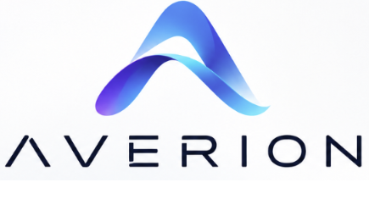
Capability Statement
Connected software for property operations teams that need clearer work, faster decisions, and accountable execution.
A practical operating layer for modern property teams  Averion Software builds focused tools that connect operational signals to the people and actions that move work forward. Cove PM brings property operations, leasing, resident communication, maintenance, payments, reporting, and Autopilot insights into one understandable workspace. | PRIMARY OFFERING  Cove PM  Property operations and workflow software
Core Capabilities
WORK ORCHESTRATION  Work orders, queues, priorities, assignments, vendor and employee coordination, and attention management. | PROPERTY OPERATIONS  Properties, units, assets, residents, communications, maintenance workflows, and operational records. | LEASING AND PAYMENTS  Lease terms, recurring charges, deposits, payments, notices, delinquency workflows, and basic accounting records.
REPORTING AND CONTROL  Operational reporting, financial reporting, audit-friendly records, permissions, and evidence-backed decisions. | AUTOPILOT INTELLIGENCE  Surfaces risk and stalled work, traces recommendations to source records, and keeps the user in control of action. | MOBILE-READY WORKFLOWS  Field-oriented experiences for technicians and inspectors, designed to keep work moving beyond the office.
Why Averion  - Useful first: focused workflows that fit the way teams already work.  - Explainable by design: recommendations remain connected to evidence and source records.  - Built to evolve: a connected foundation that can grow with each organization.  - Pilot-friendly: start with one operational problem and expand when value is proven. | Best-fit entry points  - Housing authorities and affordable housing operators  - Property management and facilities teams  - Inspection routing and field-service operations  - Teams replacing spreadsheets and disconnected queues
CONTACT  info@averionsoftware.com | WEB  averionsoftware.com | PRODUCT  covepm.averionsoftware.com
Averion Software is preparing for initial customer and public-sector pilot engagements.

